Name
Professor
Exoplanet HD 209458
26th November 2018.
Exoplanet HD 209458
Background Information
Exoplanet HD 209458b was the first planet to be discovered moving around and close to the sun. It was concealed virtually concurrently by two individuals exploiting independent radial velocity surveys, (Mazeh, 2000). The significance of this encounter was instantaneously documented. The features that were looked in the new discovery include radius, inclination, and even its atmospheric composition, (Henry, 2000). Surprisingly, the planet depicted varying features from different wavelengths, as illustrated below, showing the input to the algorithm, which are simply the extracted spectra with their median value subtracted.
Research question: How does Exoplanet HD 209458 intensity wavelength shift over time.
Hypothesis: If the wavelength fluctuates in the observations, then there is no definite trend in its features.
Independent variable: Wavelengths and Trend of Exoplanet HD 209458.
Dependent variables: Days and Hours
Control variables: Orbital Phase
Materials
Simulated Lab of Exoplanet 209458 or Micro-variability and Oscillations of STars telescope
Procedure
Algorithms were identified through the emitted light of the planet and recorded for observations at every orbital cycle for 24 hours in 29 days.
Results
Micro-Variability And Oscillations Of Stars Observation
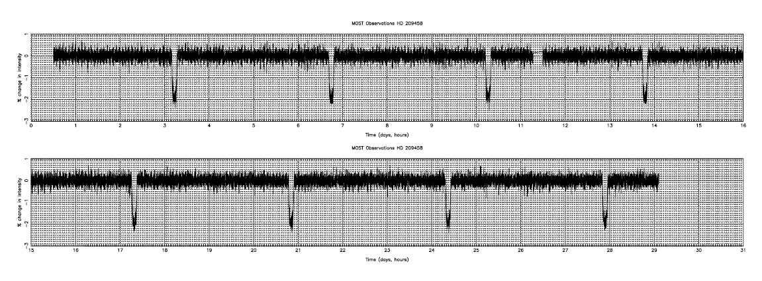
Discussion
The algorithm is repeated until no more significant global trends remain, this is up to the 4th observation. This column-by-column set-up shows the planetary signal being relatively intact since it is fluctuating in wavelength throughout the observations, thus does not establish a collective tendency in each column.
Conclusion
Reviewing the lab analysis and the existing research deductions, we can conclude that the alleged physical properties and presence of water vapor not only make the exoplanet unique but also unpredictable in various features of planets.
Work Cited
Mazeh, T. et al., 2000. The Spectroscopic Orbit of the Planetary Companion Transiting HD 209458. ApJ 532, L55–L58.
Henry, G. W., Marcy, G. W., Butler, R. P., Vogt, S. S., 2000. A Transiting “51
Peg-like” Planet. ApJ 529, L41–L44.

